Measures of Distribution Shape:
- Skewness
- Kurtosis
Skewness:
A measure of the asymmetry of the distribution.
- Positive skewness indicates a longer tail on the right side of the distribution,
- while negative skewness indicates a longer tail on the left side.

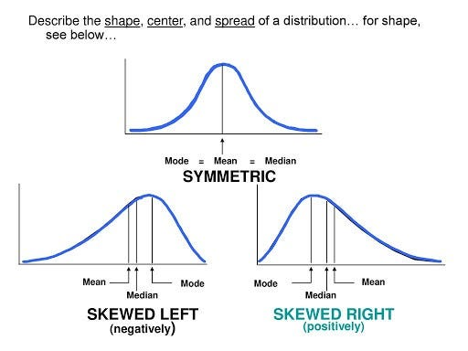

Kurtosis:
A measure of the peakedness or flatness of the distribution.
- Higher kurtosis indicates sharper, more peaked distributions,
- while lower kurtosis indicates flatter distributions.

